Oracle Database → Databricks Unity Catalog via DG4ODBC
Sep 28, 2026 · @Aviral Bhardwaj

1. Overview
Oracle Database now reads Databricks Unity Catalog tables live over a database link. In SQL*Plus, SELECT * FROM customers@DATABRICKS_LINK_TEST; returned all 5 rows of analytics.retail_demo.customers.
The bridge is Oracle Database Gateway for ODBC (DG4ODBC) on the EC2 host. It hands Oracle's SQL to the Simba Spark ODBC driver, which runs it on a Databricks SQL warehouse governed by Unity Catalog. No data is copied: each query executes in Databricks at request time.
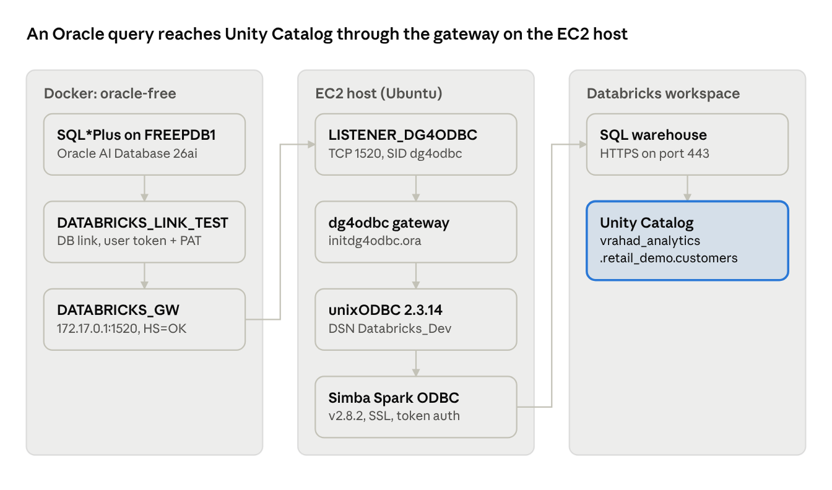
Query path · Oracle container → EC2 gateway → Databricks Unity Catalog
The Oracle container reaches the host's gateway listener over the Docker bridge (172.17.0.1, port 1520). Because the DSN sets a default catalog and schema, customers@DATABRICKS_LINK_TEST resolves to analytics.retail_demo.customers.

2. Environment and prerequisites
Everything runs on one Ubuntu EC2 instance: Oracle in a Docker container, and the gateway plus ODBC stack directly on the host.
Component | Value used in this setup
EC2 host | Ubuntu, amd64, private IP 172.31.22.17, 3.8 GiB RAM + 1 GiB swap, 28 GB root disk
Oracle database | Oracle AI Database 26ai Free 23.26.3.0.0 in container oracle-free, PDB FREEPDB1, port 1521
Oracle gateway | Oracle Database Gateways package LINUX.X64_2326100_gateways.zip, component oracle.rdbms.hsodbc, home /opt/oracle/gateway_home
ODBC driver manager | unixODBC 2.3.14 (SQLLEN size 8 bytes)
Databricks ODBC driver | Simba Spark ODBC 2.8.2.1013 at /opt/simba/spark/lib/64/libsparkodbc_sb64.so
Databricks compute | Workspace MY-DATABRICKS-URL.databricks.com, SQL warehouse HTTP path /sql/1.0/warehouses/7c327338aa2ebecb
Unity Catalog object | analytics.retail_demo.customers (customer_id, customer_name, email, city, state)
Authentication | Databricks personal access token (PAT), user name token
Before starting, confirm these are in place:
- The identity that owns the PAT has USE CATALOG on analytics, USE SCHEMA on retail_demo, SELECT on customers, and CAN USE on the SQL warehouse. Unity Catalog enforces these grants on every query Oracle sends.
- The EC2 instance can reach the workspace on outbound HTTPS 443.
- Port 1520 (gateway listener) is reachable from the Oracle container, but not opened to the internet in the security group.

3. Phase 1: Oracle Database Free in Docker
Oracle AI Database 26ai Free runs in a container named oracle-free, with data on a named volume so it survives restarts.
- Install base tools and confirm the host has room and the right architecture.
sudo apt update
sudo apt install -y unzip make gcc
free -h && df -h
dpkg --print-architecture # expect amd64
- Install Docker, pull the image and start the database.
sudo apt install -y docker.io
sudo systemctl status docker --no-pager
sudo docker pull container-registry.oracle.com/database/free:latest
sudo docker volume create OracleDBData
sudo docker run -d --name oracle-free \
-p 1521:1521 -p 5500:5500 \
-e ORACLE_PWD='<ORACLE_PWD>' \
-v OracleDBData:/opt/oracle/oradata \
container-registry.oracle.com/database/free:latest
- Confirm the listener is up and log in to the pluggable database.
sudo docker ps
sudo docker exec oracle-free bash -c "lsnrctl status"
sudo docker exec -it oracle-free sqlplus system@FREEPDB1
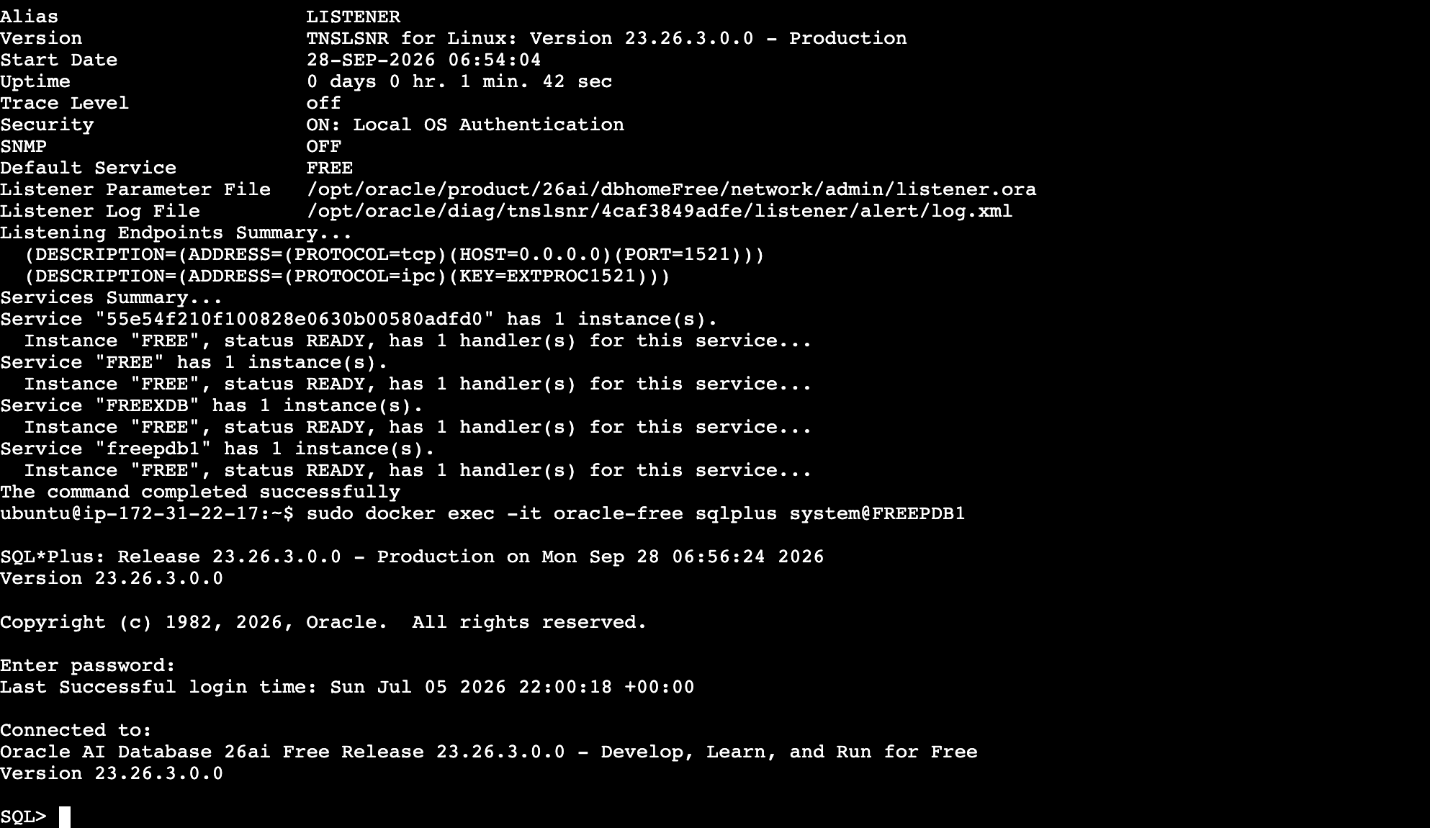
The listener reports the FREE and freepdb1 services as READY on port 1521, and SQL*Plus connects to Oracle AI Database 26ai Free 23.26.3.0.0.

4. Phase 2: Simba Spark ODBC driver
The Simba Spark ODBC driver is what actually talks to the Databricks SQL warehouse; unixODBC loads it by the name registered in /etc/odbcinst.ini.
- Install unixODBC and the driver package. The .deb needs libsasl2-modules-gssapi-mit, so install that first to avoid a broken-dependency loop.
sudo apt update
sudo apt install -y unixodbc unixodbc-dev unzip curl libsasl2-modules-gssapi-mit
curl -fL "https://databricks-bi-artifacts.s3.us-east-2.amazonaws.com/simbaspark-drivers/odbc/2.8.2/SimbaSparkODBC-2.8.2.1013-Debian-64bit.zip" \
-o SimbaSparkODBC-2.8.2.1013-Debian-64bit.zip
unzip SimbaSparkODBC-2.8.2.1013-Debian-64bit.zip
sudo dpkg -i simbaspark_2.8.2.1013-2_amd64.deb
sudo apt --fix-broken install -y
dpkg -l | grep simbaspark
ls -lh /opt/simba/spark/lib/64/libsparkodbc_sb64.so
ldd /opt/simba/spark/lib/64/libsparkodbc_sb64.so | grep "not found" # expect no output
- Register the driver with unixODBC (sudo nano /etc/odbcinst.ini).
[Simba Spark ODBC Driver 2.8.2]
Description=Simba Spark ODBC Driver 2.8.2.1013
Driver=/opt/simba/spark/lib/64/libsparkodbc_sb64.so
DriverManagerEncoding=UTF-16
- Point the driver's own config at unixODBC. Without these two lines the driver can fail to load its settings when started by the gateway.
ls -l /usr/lib/x86_64-linux-gnu/libodbcinst.so* # unversioned .so comes from unixodbc-dev
sudo tee -a /opt/simba/spark/lib/64/simba.sparkodbc.ini > /dev/null <<'EOF'
DriverManagerEncoding=UTF-16
ODBCInstLib=/usr/lib/x86_64-linux-gnu/libodbcinst.so
EOF
sudo grep -E '^(DriverManagerEncoding|ODBCInstLib|ErrorMessagesPath)' \
/opt/simba/spark/lib/64/simba.sparkodbc.ini
- Verify the registration.
odbcinst -j # unixODBC 2.3.14, SQLLEN Size: 8
odbcinst -q -d # lists [Simba Spark ODBC Driver 2.8.2]
Note the SQLLEN Size: 8 value from odbcinst -j. It decides the gateway's HS_FDS_SQLLEN_INTERPRETATION setting in Phase 5.

5. Phase 3: DSN on Unity Catalog and direct test
The DSN Databricks_Dev pins the session to Unity Catalog catalog analytics and schema retail_demo, and a direct isql test from the host returned live UC data before any Oracle work began.
- Create the DSN (sudo nano /etc/odbc.ini).
[ODBC]
Trace=yes
TraceFile=/tmp/odbctrace.log
[Databricks_Dev]
Catalog=analytics
Schema=retail_demo
Driver=Simba Spark ODBC Driver 2.8.2
Host=MY-DATABRICKS-URL.databricks.com
Port=443
HTTPPath=/sql/1.0/warehouses/7c327338aa2ebecb
SSL=1
ThriftTransport=2
AuthMech=3
UID=token
PWD=<DATABRICKS_PAT>
PWD=<DATABRICKS_PAT>
Setting | What it does
Catalog=analytics | Default Unity Catalog catalog for every session on this DSN
Schema=retail_demo | Default schema, so an unqualified customers resolves to analytics.retail_demo.customers
HTTPPath | The SQL warehouse that executes the queries
ThriftTransport=2, SSL=1, Port=443 | Thrift over HTTPS, as Databricks requires
AuthMech=3, UID=token, PWD | User/password auth where the user is the literal word token and the password is the PAT
Trace=yes | Logs every ODBC call to /tmp/odbctrace.log; turn off once working
- Confirm the DSN is visible, then connect.
odbcinst -q -s # lists [Databricks_Dev]
export DATABRICKS_TOKEN='<DATABRICKS_PAT>'
isql -v Databricks_Dev token "$DATABRICKS_TOKEN"
- At the SQL> prompt, check that Unity Catalog is what answers.
SHOW CATALOGS;
SHOW TABLES IN analytics.retail_demo;
SELECT customer_id, customer_name, email, city, state
FROM analytics.retail_demo.customers;
SELECT * FROM analytics.retail_demo.supermarket_gold LIMIT 10;
SELECT * FROM vrahad_analytics.retail_demo.supermarket_gold LIMIT 10;
Captured output (isql's wide borders condensed):
SQL> show catalogs
catalog
hive_metastore
insurance_command_center
lead_generation
newtesting_catalog
samples
system
test_delta_share
analytics
8 rows fetched
SQL> SHOW TABLES IN analytics.retail_demo;
customers, gold_city_sales, gold_payment_sales, order_items, orders,
pipeline_category_sales, products, stores, supermarket_bronze,
supermarket_gold, supermarket_silver
11 rows fetched
SQL> SELECT * FROM analytics.retail_demo.supermarket_gold LIMIT 10;
product_line total_transactions total_quantity total_sales total_profit
Home and lifestyle 32 168 12019.5 572.34
Electronic accessories 34 199 11400.01 542.86
Food and beverages 35 191 10790.75 513.84
Fashion accessories 36 156 10337.73 492.26
Health and beauty 30 176 9973.89 474.97
Sports and travel 33 177 9857.04 469.39
6 rows fetched
6 rows fetched
The customers query returned 5 rows: Amit Sharma, Priya Singh, Rahul Verma, Neha Gupta and Rohit Kumar. The system catalog in the list exists only on Unity Catalog-enabled workspaces, and the three-level name resolves, so the driver is reading through Unity Catalog, not the legacy Hive metastore.

6. Phase 4: Install Oracle Database Gateway for ODBC
Only the ODBC gateway component (oracle.rdbms.hsodbc) is installed, silently, into /opt/oracle/gateway_home on the EC2 host. Ubuntu is not an Oracle-certified OS, so two Linux fixes are needed along the way.
- Download and stage the gateway package. The download link is signed per Oracle account and expires, so generate a fresh one from Oracle's site.
wget -O LINUX.X64_2326100_gateways.zip "<SIGNED_ORACLE_DOWNLOAD_URL>"
sha256sum LINUX.X64_2326100_gateways.zip
mkdir -p ~/gateway_staging
unzip -q LINUX.X64_2326100_gateways.zip -d ~/gateway_staging
- Create the install group and directories so the ubuntu user can run the installer without a separate oracle OS user. Log out and back in afterwards, then check with groups.
sudo groupadd oinstall
sudo usermod -aG oinstall ubuntu
sudo mkdir -p /opt/oracle/gateway_home /opt/oracle/oraInventory
sudo chown -R ubuntu:oinstall /opt/oracle
- Prepare the response file.
cp ~/gateway_staging/gateways/response/gateways.rsp ~/gateway_install.rsp
sed -i \
-e 's|^UNIX_GROUP_NAME=.*|UNIX_GROUP_NAME=oinstall|' \
-e 's|^INVENTORY_LOCATION=.*|INVENTORY_LOCATION=/opt/oracle/oraInventory|' \
-e 's|^ORACLE_HOME=.*|ORACLE_HOME=/opt/oracle/gateway_home|' \
-e 's|^ORACLE_BASE=.*|ORACLE_BASE=/opt/oracle|' \
-e 's|^oracle.install.tg.customComponents=.*|oracle.install.tg.customComponents={oracle.rdbms.hsodbc:23.0.0.0.0}|' \
~/gateway_install.rsp
grep -E "^(UNIX_GROUP_NAME|INVENTORY_LOCATION|ORACLE_HOME|ORACLE_BASE|oracle.install.tg.customComponents)=" \
~/gateway_install.rsp
- Add swap. The installer requires more than 150 MB of swap and the instance had none.
sudo fallocate -l 1G /swapfile
sudo chmod 600 /swapfile
sudo mkswap /swapfile
sudo swapon /swapfile
echo '/swapfile none swap sw 0 0' | sudo tee -a /etc/fstab
- Link the C runtime objects where Oracle's makefile expects them. On the first run the prerequisite checks passed, but relinking idg4odbc failed with a FATAL error: Oracle looks for crt1.o, crti.o and crtn.o in /usr/lib64, while Ubuntu ships them in /usr/lib/x86_64-linux-gnu.
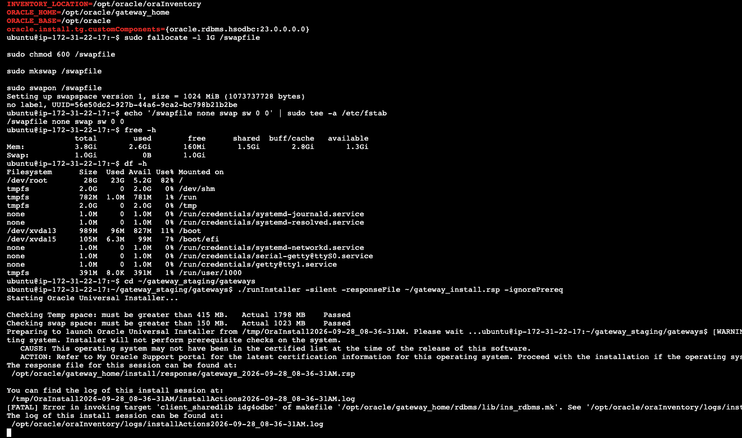
sudo apt install --reinstall -y libc6-dev build-essential
sudo mkdir -p /usr/lib64
sudo ln -sf /usr/lib/x86_64-linux-gnu/crti.o /usr/lib64/crti.o
sudo ln -sf /usr/lib/x86_64-linux-gnu/crtn.o /usr/lib64/crtn.o
sudo ln -sf /usr/lib/x86_64-linux-gnu/crt1.o /usr/lib64/crt1.o
- Run the installer (clearing any failed attempt first), then the two root scripts.
rm -rf /opt/oracle/gateway_home/* /opt/oracle/oraInventory/* # only after a failed attempt
cd ~/gateway_staging/gateways
./runInstaller -silent -responseFile ~/gateway_install.rsp -ignorePrereq
cd ~
sudo /opt/oracle/oraInventory/orainstRoot.sh
sudo /opt/oracle/gateway_home/root.sh
find /opt/oracle/gateway_home -iname "*dg4odbc*" # gateway binary present
-ignorePrereq is required because the installer does not recognise Ubuntu; the warning in the screenshot above is expected.

7. Phase 5: Gateway and listener configuration
The gateway is wired to the DSN through initdg4odbc.ora, and a dedicated listener on port 1520 starts it with the exact environment the ODBC stack needs. The SID dg4odbc must match in three places: the init file name, the listener's SID_NAME, and the Oracle-side tnsnames.ora entry.
- Back up and write the gateway init file (sudo nano /opt/oracle/gateway_home/hs/admin/initdg4odbc.ora).
sudo cp /opt/oracle/gateway_home/hs/admin/initdg4odbc.ora \
/opt/oracle/gateway_home/hs/admin/initdg4odbc.ora.bak

HS_FDS_CONNECT_INFO=Databricks_Dev
HS_FDS_SHAREABLE_NAME=/usr/lib/x86_64-linux-gnu/libodbc.so.2
HS_FDS_TRACE_LEVEL=DEBUG
HS_FDS_SUPPORT_STATISTICS=FALSE
HS_FDS_QUOTE_IDENTIFIER=TRUE
HS_FDS_SQLLEN_INTERPRETATION=64
HS_LANGUAGE=AMERICAN_AMERICA.AL32UTF8
HS_NLS_NCHAR=UCS2
set ODBCINI=/etc/odbc.ini
set ODBCSYSINI=/etc
set SIMBASPARKINI=/opt/simba/spark/lib/64/simba.sparkodbc.ini
Parameter | Why it is set this way
HS_FDS_CONNECT_INFO | The DSN from Phase 3
HS_FDS_SHAREABLE_NAME | The unixODBC driver manager libodbc.so.2, not libodbcinst.so.2 (the installer library)
HS_FDS_SQLLEN_INTERPRETATION=64 | Matches unixODBC's 8-byte SQLLEN; the earlier value of 32 broke the connection
HS_FDS_SUPPORT_STATISTICS=FALSE | Stops Oracle asking the driver for table statistics during query planning
HS_LANGUAGE, HS_NLS_NCHAR | UTF-8 / UCS2 character handling to match the driver's UTF-16 encoding
HS_FDS_TRACE_LEVEL=DEBUG | Gateway trace for setup; set to OFF once stable
set ... lines | Environment the dg4odbc process needs to find the DSN and driver config
- Write the gateway listener (/opt/oracle/gateway_home/network/admin/listener.ora). The listener starts dg4odbc with an almost empty environment, so everything the driver needs goes in ENVS.
SID_LIST_LISTENER_DG4ODBC =
(SID_LIST =
(SID_DESC =
(SID_NAME = dg4odbc)
(ORACLE_HOME = /opt/oracle/gateway_home)
(PROGRAM = dg4odbc)
(ENVS = "LD_LIBRARY_PATH=/opt/oracle/gateway_home/lib:/opt/simba/spark/lib/64:/usr/lib/x86_64-linux-gnu,ODBCINI=/etc/odbc.ini,ODBCSYSINI=/etc,SIMBASPARKINI=/opt/simba/spark/lib/64/simba.sparkodbc.ini")
)
)
LISTENER_DG4ODBC =
(DESCRIPTION_LIST =
(DESCRIPTION =
(ADDRESS = (PROTOCOL = TCP)(HOST = 0.0.0.0)(PORT = 1520))
)
)
- Give Oracle the libaio.so.1 name it expects. This Ubuntu release ships the library as libaio.so.1t64.*, and the listener will not start without the old name.
find / -iname "libaio*" 2>/dev/null # this host had libaio.so.1t64.0.2
sudo ln -sf /usr/lib/x86_64-linux-gnu/libaio.so.1t64.0.2 /usr/lib/x86_64-linux-gnu/libaio.so.1
sudo ldconfig
- Start (or restart) the listener with the full environment, then confirm port 1520 is listening.
sudo pkill -TERM -f 'tnslsnr LISTENER_DG4ODBC'
sleep 5
sudo env \
ORACLE_HOME=/opt/oracle/gateway_home \
TNS_ADMIN=/opt/oracle/gateway_home/network/admin \
LD_LIBRARY_PATH=/opt/oracle/gateway_home/lib:/opt/simba/spark/lib/64:/usr/lib/x86_64-linux-gnu \
ODBCINI=/etc/odbc.ini ODBCSYSINI=/etc \
SIMBASPARKINI=/opt/simba/spark/lib/64/simba.sparkodbc.ini \
nohup /opt/oracle/gateway_home/bin/tnslsnr LISTENER_DG4ODBC \
> /tmp/listener_dg4odbc.log 2>&1 &
sleep 8
sudo ss -ltnp | grep ':1520'
- Prove the ODBC stack works in the gateway's stripped-down environment. env -i clears every variable except the ones listed, which is how dg4odbc sees the world.
sudo env -i \
HOME=/root \
PATH=/usr/bin:/bin \
LD_LIBRARY_PATH=/opt/oracle/gateway_home/lib:/opt/simba/spark/lib/64:/usr/lib/x86_64-linux-gnu \
ODBCINI=/etc/odbc.ini \
ODBCSYSINI=/etc \
SIMBASPARKINI=/opt/simba/spark/lib/64/simba.sparkodbc.ini \
/usr/bin/isql -v Databricks_Dev token "$DATABRICKS_TOKEN"
# If it fails, read the ODBC trace
sudo tail -100 /tmp/odbctrace.log
sudo grep -iE "SQLConnect|error|fail|SQLSTATE|Auth" /tmp/odbctrace.log | tail -100
The test connected, confirming the gateway's environment, the SQLLEN fix and the Simba settings work together.

8. Phase 6: Oracle side, tnsnames entry and database link
Inside the Oracle container, a tnsnames.ora alias points at the host's gateway listener, and a database link uses that alias with the PAT as its password.
- Find the host's address as seen from the container, and check that port 1520 is reachable.
sudo docker exec oracle-free bash -c "ip route | grep default"
# default via 172.17.0.1 dev eth0 <- the EC2 host on the Docker bridge
sudo docker exec oracle-free bash -c \
"timeout 3 bash -c '</dev/tcp/172.17.0.1/1520' && echo OPEN || echo CLOSED"
- Add the gateway alias to the container's tnsnames.ora, then test it. (HS = OK) tells Oracle the target is a Heterogeneous Services gateway, not another Oracle database.
sudo docker exec -u oracle oracle-free bash -c "cat >> /opt/oracle/product/26ai/dbhomeFree/network/admin/tnsnames.ora <<'EOF'
DATABRICKS_GW =
(DESCRIPTION =
(ADDRESS = (PROTOCOL = TCP)(HOST = 172.17.0.1)(PORT = 1520))
(CONNECT_DATA = (SID = dg4odbc))
(HS = OK)
)
EOF"
sudo docker exec oracle-free bash -c "tnsping DATABRICKS_GW"
Open question: the captured shell history cuts off inside this command, so the entry above is rebuilt from the values used elsewhere (host 172.17.0.1, port 1520, SID dg4odbc). Compare it with the live file before publishing.
- Create the database link from SQL*Plus.
sudo docker exec -it oracle-free sqlplus system@FREEPDB1

CREATE PUBLIC DATABASE LINK DATABRICKS_LINK_TEST
CONNECT TO "token" IDENTIFIED BY "<DATABRICKS_PAT>"
USING 'DATABRICKS_GW';
SELECT owner, db_link, username, host
FROM all_db_links
WHERE db_link LIKE 'DATABRICKS%';
The double quotes around token keep it lowercase; unquoted, Oracle would send TOKEN and Databricks would reject the login. The gateway passes this user and password to the driver as UID and PWD.

9. Phase 7: End-to-end proof from Oracle
Oracle SQL*Plus read the Unity Catalog table analytics.retail_demo.customers through the link and returned all 5 rows: Amit Sharma, Priya Singh, Rahul Verma, Neha Gupta and Rohit Kumar.
-- inside: sudo docker exec -it oracle-free sqlplus system@FREEPDB1
SELECT * FROM dual@DATABRICKS_LINK_TEST; -- link and gateway are alive
SELECT * FROM customers@DATABRICKS_LINK_TEST; -- live read of the UC table
Why this is a Unity Catalog connection, not just a Databricks one:
- The rows match the direct UC query in Phase 3 name for name, so Oracle is reading the same governed table.
- customers resolves through the DSN's default catalog analytics, a Unity Catalog catalog; UC checks the PAT owner's grants on every query Oracle sends.
- The same connection lists the system catalog, which exists only on Unity Catalog-enabled workspaces.
Other objects in retail_demo work the same way, for example SELECT * FROM orders@DATABRICKS_LINK_TEST;. Reaching a different catalog needs either a second DSN with its own Catalog= (plus its own gateway SID and link) or DBMS_HS_PASSTHROUGH with native three-part names; neither was tested in this setup.
- ☐ Add a screenshot of the customers@DATABRICKS_LINK_TEST result here (none was in the uploaded files)
- ☐ Add a screenshot of the Databricks SQL warehouse Query History showing the Oracle-originated query

10. Troubleshooting: issues hit and their fixes
Every row below happened during this build; the fixes are already folded into the phases above, in the order they occur.
Symptom | Cause | Fix
dpkg -i simbaspark_*.deb leaves the package half-installed | Missing SASL GSSAPI module dependency | sudo apt install -y libsasl2-modules-gssapi-mit, then sudo apt --fix-broken install -y
Installer warns the OS is not certified | Ubuntu is not on Oracle's certified list | Run with -ignorePrereq
Installer swap check fails | Instance had no swap; installer needs more than 150 MB | Create a 1 GB swapfile and add it to /etc/fstab
[FATAL] Error in invoking target 'client_sharedlib idg4odbc' | Oracle's makefile looks for crt*.o in /usr/lib64 | Reinstall libc6-dev, symlink the three crt*.o files, wipe the home and inventory, rerun
Listener will not start, libaio.so.1 not found | Ubuntu renamed it libaio.so.1t64 | Symlink to libaio.so.1, run ldconfig
lsnrctl complains about message files or its home | ORACLE_HOME and TNS_ADMIN not exported | Export ORACLE_HOME, TNS_ADMIN, PATH, LD_LIBRARY_PATH before starting
Gateway cannot load the ODBC driver manager | HS_FDS_SHAREABLE_NAME pointed at libodbcinst.so.2 | Point it at /usr/lib/x86_64-linux-gnu/libodbc.so.2
Connection or fetch fails through the gateway only | HS_FDS_SQLLEN_INTERPRETATION=32 against unixODBC's 8-byte SQLLEN | Set it to 64
isql works in your shell but the link fails | Listener starts dg4odbc with a near-empty environment | Put all paths in listener ENVS and set lines; verify with the env -i test
Login rejected over the link | Unquoted user name is upper-cased to TOKEN | CONNECT TO "token" with double quotes
Link fails after an EC2 reboot | Container and gateway listener do not auto-start | sudo docker start oracle-free, then rerun Phase 5 step 4
One clean-up item: the tee -a into simba.sparkodbc.ini ran three times during setup. Check with grep -c '^ODBCInstLib' /opt/simba/spark/lib/64/simba.sparkodbc.ini and remove duplicate lines if the count is above 1.

11. Security and production hardening
Rotate the Databricks PAT first: the working notes behind this document hold it in plain text (shell history, odbc.ini, and the CREATE DATABASE LINK statement). This document uses <DATABRICKS_PAT> placeholders throughout.
- ☐ Revoke the current PAT in Databricks and issue a new one, ideally for a service principal holding only the Unity Catalog grants listed in section 2
- ☐ Put the new token in /etc/odbc.ini, recreate DATABRICKS_LINK_TEST, and drop the earlier DATABRICKS_LINK if it is no longer used
- ☐ Remove token lines from ~/.bash_history and run unset DATABRICKS_TOKEN
- ☐ sudo chmod 600 /etc/odbc.ini so only root can read the credentials
- ☐ Turn tracing off (Trace=no in odbc.ini, HS_FDS_TRACE_LEVEL=OFF) and delete /tmp/odbctrace.log, which can hold connection details
- ☐ Replace the PUBLIC link with a private link in the schema that needs it; a public link lets every Oracle user query Unity Catalog as the PAT owner
- ☐ Change the Oracle ORACLE_PWD set at container creation; the setup value was a weak default
- ☐ Keep port 1520 closed to the internet in the EC2 security group, or bind the listener to 172.17.0.1 instead of 0.0.0.0
- ☐ Run the gateway listener as a dedicated OS user under a systemd unit instead of nohup as root, and start the container with --restart unless-stopped
- ☐ Test removing PWD from odbc.ini, since the database link already supplies the credentials to the driver

